Name - Akshat Sharma

Section - B

Batch - B2 Roll No - 28

Subject - Computer Vision TA-2 Mini Project

**1. Implement the SIFT algorithm to detect and match key points between two images.**

**Original Images**

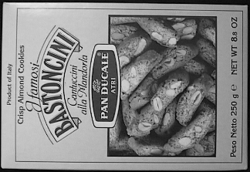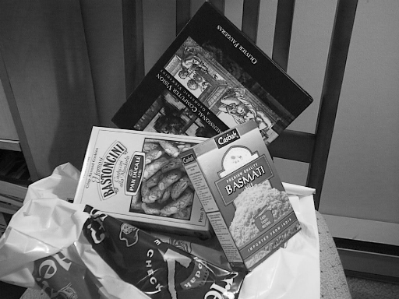

**Output Image**

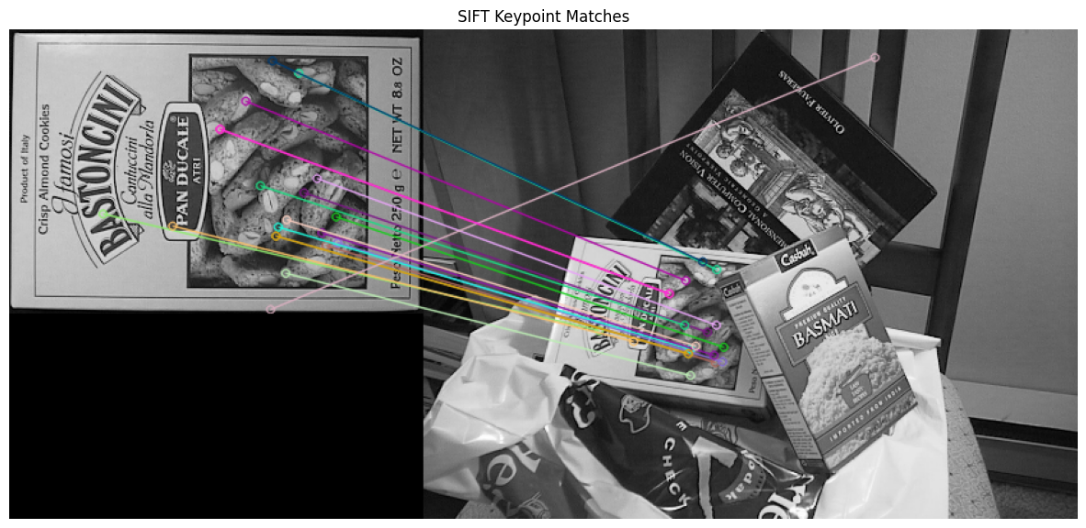

**2. Use RANSAC to remove outlier key point matches and fit a transformation model between two images.**

**Original image**

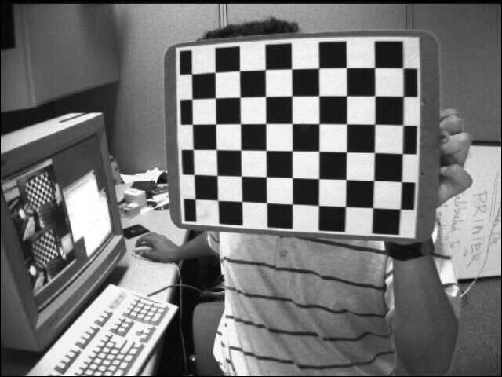

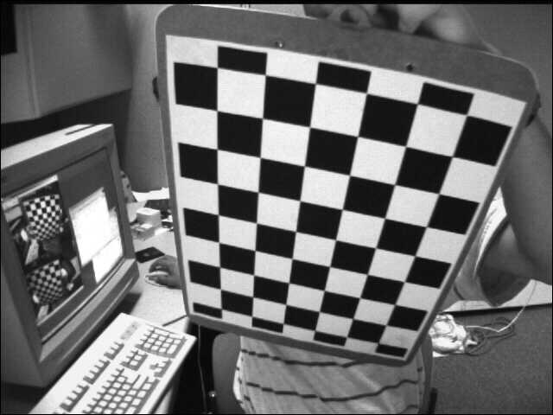

**Output Image**

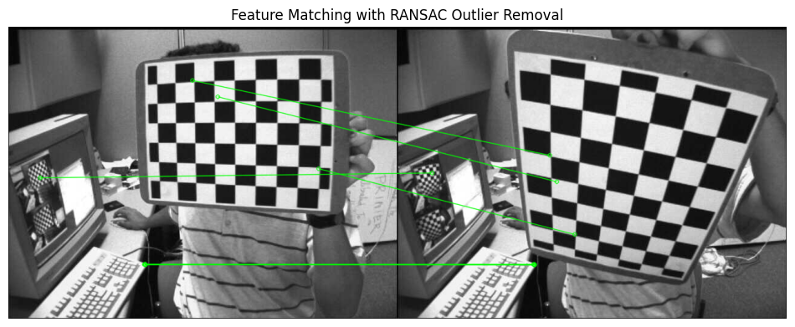

**3. Implement the Harris corner detector to find and visualize corners in a grayscale image.**

**Original image**

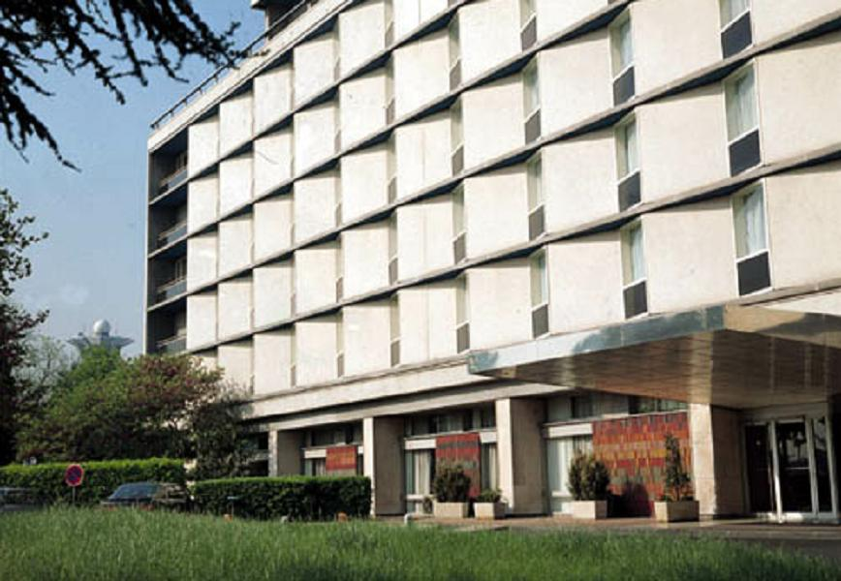

**Output Image**

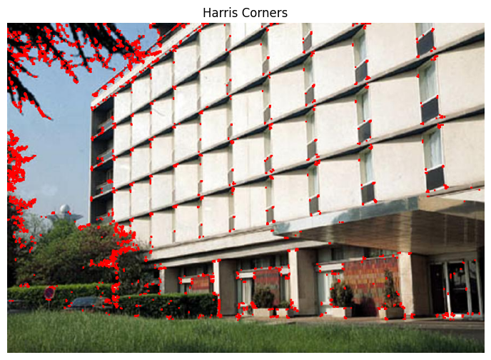

**GitHub Link -** <https://github.com/Akshat-6/Computer-Vision->

